5. SYSTEM ARCHITECTURE

This chapter describes the system architecture with the available components, how it is the best in its way, its pros and cons and why the other alternatives available have not been considered.

5.1 SYSTEM ARCHITECTURE AND DESIGN

This section describes the logical model of the system and its architecture as to what components are to be used, where and how.

5.1.1 Type of components required and used

- Microcontroller

A microcontroller is needed to program the robot as per the requirements. A microcontroller is chosen instead of a microprocessor because the former has a microprocessor in it, in addition to which it has other important features like timers, ram, rom, interrupts, etc. built in on a single chip. When finalizing a microcontroller, along with its features, the cost constraints should also be taken into consideration, to make sure that all the constraints are met. The microcontroller we have chosen for our project is ATMEL ATMEGA8. This was finalized because it was the best option satisfying the cost constraints and fulfilling all the needs. In addition it has certain important features like In System Programming, independent Flash and EEPROM memories, etc.

- Distributed CPU v/s Single CPU

In a distributed CPU architecture, as the name suggests, CPUs can be interfaced on a large scale and communication between them can be made possible, thus leading to an increase in the through-put of the system and enabling it to perform a lot many functions than it could do if it were a single system. Also many external devise like sensors, timers, motors, etc. can be interfaced. There are certain drawbacks of using a distributed system like increased complexity, need for more hardware, etc. but these are negligible in comparison to the advantage it provides. This approach can be used in situations where we need a multitasking system performing a large number of functions.
In a single CPU architecture there is just one CPU which controls the entire system, hence reducing the complexity and hardware, system overhead, etc. in comparison to distributed CPU architecture. This approach has certain disadvantages also like the CPU is limited to perform only certain number of actions. This architecture can be used when the system is very simple and has not to perform many functions.
We chose to use the distributed CPU architecture because of the large number of functions the system performs. Also future enhancements are very much possible in the system and using this architecture increases the flexibility of the system for the same.

- Sensors

Sensors are needed in our system for two purposes :–
1. Detecting an obstacle.
2. Tracking the path.
For detecting any objects in the range set according to potentiometer, the sensor used should convey to the system that there is an obstacle in its region. The sensor used for such task should be sensitive enough to detect any obstructions in its dormitory which can be done with a IR led that throws light rays and the sensors detect it. In case of obstruction the rays reflected back are different and thus obstacle is detected. This kind of mechanism is required to detect obstacle. A problem with such a sensor is that it cannot detect any black colored objects because they don’t reflect any light, in contrary they’ll absorb all the rays thrown by the sensor.
A similar mechanism is used by the sensors used to track path. Hence, they walk on a black path.
We have used TSOP sensors for obstacle detection because of its high sensitivity and IR sensors as path detectors which can easily track path.

- Battery used

The battery used in our system is a Lithium ion battery. Li-ion batteries are now-a-days becoming a practical alternative for robot power. They are smartly packed to avoid any accidents and are long lasting and can be charged very quickly, i.e. it takes a maximum of two hours to get charged from dead to full. It has certain drawbacks like the cost of its charger is high and hard to find compared to other batteries in use. It also has chances of damage or explosion. Also the voltage is not constant, i.e. in that the battery operates over a range of 12V – 10.8V when fully charged, which may be a problem in certain cases, not in ours.

- Motors

The motors used are reversible, 100 rpm, requiring 12V supply. In total, three motors are used in the system, two of them for driving the wheels of the robot and one for the gripper.

- Gripper architecture

The gripper is used for pick and place of objects. Many gripper designs have been studied which are available on the internet. Almost all of them use two or more motors for its working, i.e. the gripper drive, then its pick and place actions. The use of more motors increases the load on the system. To reduce this, a design using just a single motor was to be implemented which seemed to be necessary and sufficient requirement for the gripper to work properly.
The gripper we designed for our system includes a single motor which drives the gripper, and also does the pick and place. The proposed design uses thread links to perform both the gripper functions as stated above, using a ‘reversible’ 100rpm motor. The motor shaft winds and unwinds two strings at a time which in turn opens, closes, lifts up and down the gripper jaws, as desired is shown in the Figure 1. below.

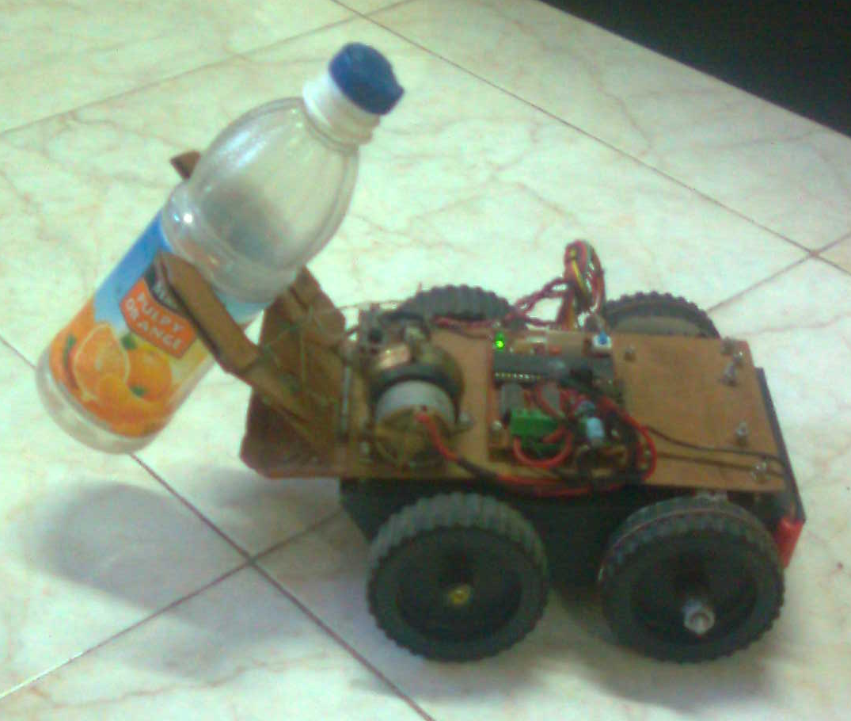

Figure 5.1 Gripper in action

The Figure 2. shows the construction of the gripper. It consists only of three parts connected to the robot base using a common door hinge. The gripper arms are connected to the lifter platform using bolted joints and the pull points of the gripper arms are connected to the motor using strong threads which respond to the motor motion. The lever action used to open, close, lift and place is done with a counter spring to avoid ‘backlash’. The construction time with the help of minimal tools like hex saw and drill is less than one hour.

Thread links
Gripper arm

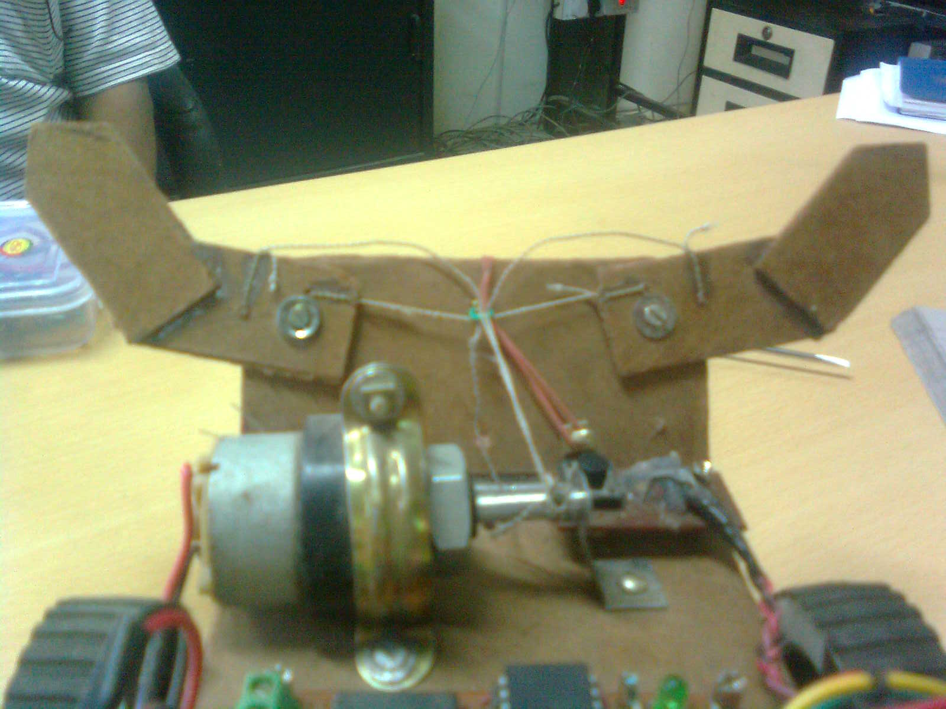
Motor
Lifter platform

Figure 5.2 Construction of gripper

5.1.2 System Architecture

After a thorough study of the components to be used and how, the system is designed such that it uses all possible resources in the best possible way.
The Figure 5.3 shows a block diagram of the system. As it can be seen in the diagram, two CPUs are interfaced with each other. The first CPU is used for remote interface, obstacle detector and gripper and the second CPU is used for the line tracker module. The microcontroller ATMEGA8 has 3 I/O ports of which two are 8-bit and one is 7-bit. The ports used for each module are also shown.
- Obstacle avoider uses
- Line tracker uses
- Gripper uses
- Remote interface uses

Obstacle avoider

CPU 1
CPU 2
Gripper
Motors

Line tracker
Remote interface

